Jason Carignan
CS 499 – Computer Science Capstone
Professor Satish Penmatsa
January 30, 2026
4-2 Milestone Three: Enhancement Two: Algorithms and Data Structure
The artifact selected for this enhancement is a Course Planner application originally developed in CS 300, Data Structures and Algorithms, as a console-based advising tool that loads course records from a CSV file, stores them in a hash table, and prints either a full course list or a single course with its prerequisites. The original implementation met the functional requirements, but it relied on sorting the full course list every time the schedule was printed, and it did not support more advanced prerequisite analysis such as prerequisite chains or cycle detection. For CS 499, this artifact was selected because it provides a clear opportunity to demonstrate algorithmic improvement, efficiency measurement, and more realistic advising functionality using graph-based structures.
At a high level, the enhancement improves the system in three meaningful ways: it eliminates unnecessary repeated computation, expands prerequisite reasoning beyond direct dependencies, and strengthens safeguards that prevent unstable execution. The result is a more scalable and realistic advising system that better reflects professional software expectations.
To better demonstrate the impact of these algorithmic improvements, the CSV file was expanded significantly beyond the small academic dataset used in CS 300. The updated ProjectTwo_Enhanced.csv includes a much larger set of courses and prerequisite relationships, allowing performance differences between the legacy and enhanced approaches to be measured under more realistic data volumes rather than trivial cases.
For this enhancement, the program was expanded and refactored to strengthen both performance and capability while preserving the original user experience. The first improvement eliminates repeated sorting by maintaining an always sorted index of course IDs using a std::set. This change removes the need to rebuild and sort an ID list on every schedule print, which directly improves runtime when users print schedules repeatedly. To preserve traceability to the original design, the original CS 300 implementation was retained in the project archive as ProjectTwo_Original.txt, allowing reviewers to clearly compare the before-and-after versions without interfering with compilation or execution.
The second major enhancement introduces a prerequisite graph represented as an adjacency list. Each course maps to its direct prerequisites, which allows the program to evaluate prerequisites using graph traversal rather than only printing direct dependencies. On top of this structure, a depth-first search (DFS) algorithm expands full prerequisite chains, and memoization is used to cache results so repeated prerequisite lookups are efficient. This approach improves realism because it mirrors how real advising systems often need to display not only direct prerequisites but also the entire sequence of courses a student must complete. The DFS implementation also includes recursion stack tracking to detect prerequisite cycles. If the CSV contains a circular dependency, the program reports an error rather than recursing indefinitely, which is both a correctness improvement and a practical safeguard.
One challenge encountered during implementation involved ensuring that recursive traversal did not repeatedly evaluate shared prerequisite paths. Early testing revealed redundant evaluations within deeper dependency chains. By introducing memoization, previously computed prerequisite expansions were stored and reused, eliminating unnecessary repeated work and significantly improving efficiency. Another challenge involved benchmarking fairness. Console output time initially distorted measurements, so the benchmarking logic was adjusted to isolate internal computation from display operations, ensuring accurate comparison between the legacy and enhanced approaches.
The performance demonstration was updated to avoid printing course lists during benchmarking, because console output is slow and can hide algorithm differences. Instead, the benchmark isolates the work performed by each approach. The enhanced path iterates the already sorted set of course IDs and touches course data, while the legacy path rebuilds and sorts an ID list each iteration and touches the same course data, which keeps the comparison fair. With the expanded dataset in ProjectTwo_Enhanced.csv, the updated approach iterated larger files and repeated the schedule work many more times. As shown in the performance and menu demonstration screenshot below, the enhanced method completed the repeated schedule workload approximately 9.5 times faster than the legacy method.
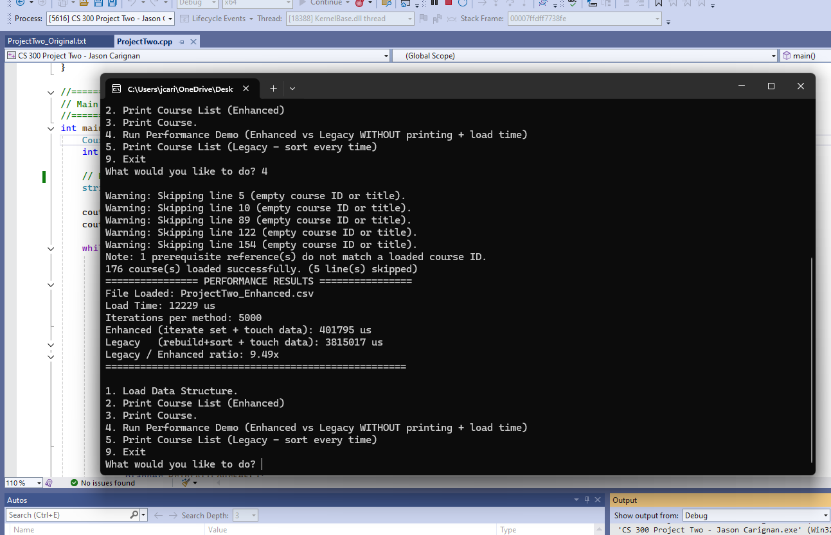
This screenshot demonstrates both the improved runtime performance and the expanded prerequisite output visible through the enhanced menu workflow.
These enhancements support the Computer Science program outcomes in concrete ways. The project demonstrates designing and evaluating computing solutions by selecting data structures that match the problem domain, including hash-based storage for fast lookups, a set for ordered iteration, and a graph for prerequisite reasoning. The work also demonstrates modern tools and techniques by using defensive parsing, structured helper functions for normalization, and lightweight benchmarking using the C++ standard library timing utilities. Communication is supported through clear code organization, consistent naming, and comments that explain the purpose of each design decision and algorithm. A security mindset is reflected through input validation and defensive behaviors, including trimming whitespace, normalizing IDs, rejecting invalid rows, preventing duplicates, and detecting cycles that could otherwise lead to unstable execution. Collaboration is supported through the structured design, because the separation between parsing, storage, graph building, and reporting makes the code easier for others to understand, test, and extend.
Overall, this enhancement strengthened the artifact by making it more realistic, more efficient under repeated use, and more resilient to imperfect input data. It demonstrates measurable performance improvement through appropriate data structure selection, and it expands the original scope by adding graph traversal, memoization, and cycle detection. The resulting application better reflects professional expectations for advising software, where both correctness and efficiency matter, and where prerequisite logic often extends beyond direct dependencies.

